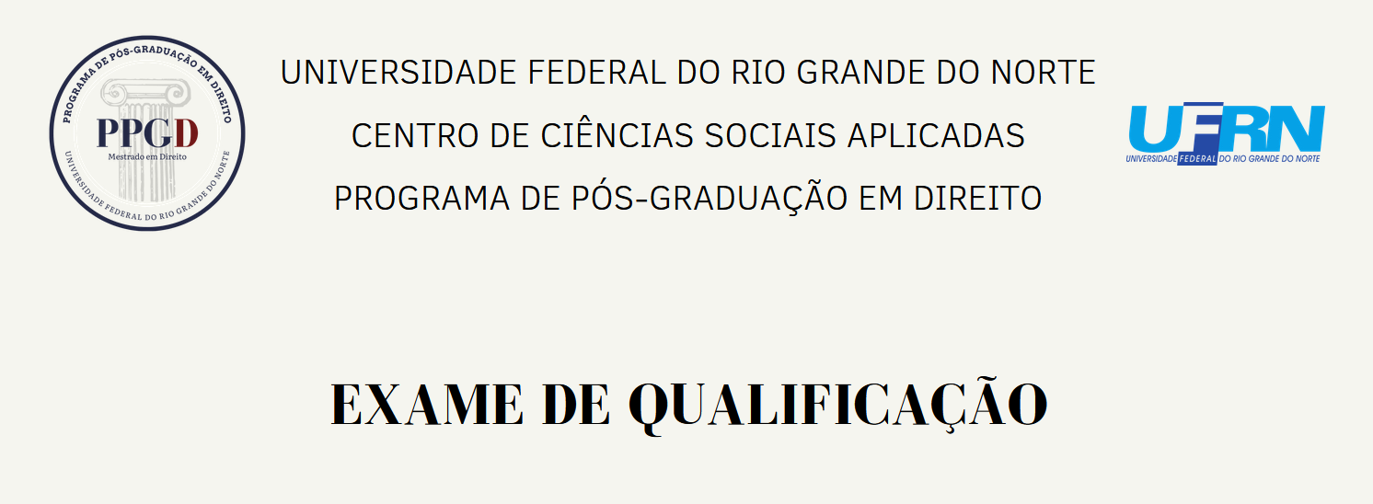

MESTRANDO(A):

TÍTULO:

DATA:

PARECER:

BANCA EXAMINADORA:

_________________________________________________

Orientador(a)

_________________________________________________

Examinador(a) interno(a)

_________________________________________________

Examinador(a) interno(a)