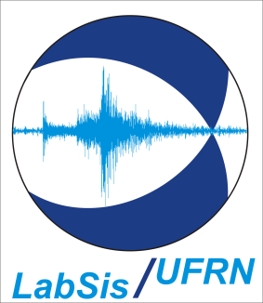
CICLO DE SEMINÁRIOS LABSIS 2015 - DÉCIMO SEMINÁRIO
Data: 12/11/2015
Horário: 16h30min
Local: Auditório do departamento de Geofísica (prédio REUNI)
Ministrante: Prof Dr. Xavier Garcia (Barcelona Center for Subsurface Imaging)

Título: An introduction to magnetotellurics… And a couple of examples

Resumo:
Electromagnetic methods are geophysical techniques widely used by both
academia and industry. In the present talk I start with a broad
introduction to the method, reviewing the mathematical background,
introduce resistivity and finishing with a classification into natural
and controlled source methods. In the second part I introduce the BODES
experiment, showing preliminary results from processing. Finally, I will
show results from a Marine Magnetotelluric survey in southern Spain to
study a very complex convergence margin.

